ONLINE RECRUITMENT SYSTEM

***FOURTH INCREMENT***



3/10/2014

UMKC

Deepthi Jonnalagadda& Preethi Reddy Pesaru

**FOURTH INCREMENT REPORT**

Class Diagram:

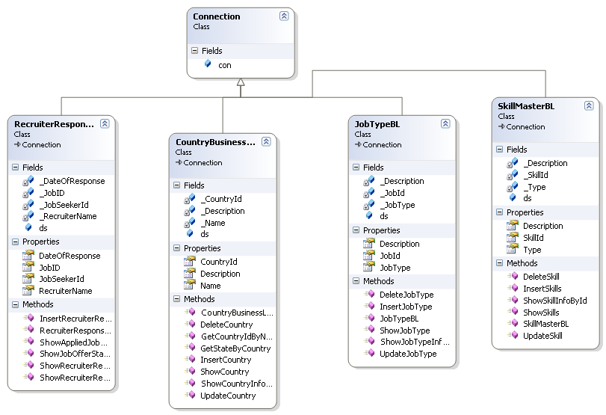

**SEQUENCE DIAGRAMS**

Sequence Diagrams Represent the objects participating the interaction horizontally and time vertically.

Admin Login



Admin Add Country Sequence Diagram



Admin Add State Sequence Diagram



Admin Add City Sequence Diagram



Jobseeker Update Profile Sequence Diagram



JobRecuriter Update Profile Sequence Diagram



Registration Sequence Diagram

Registration

BAL : ClsRegistration

DAL : SqlHelper

DataBase

1 : Registration()

2 : ExecuteNonQuery()

3 : ExecuteNonQuery()

4 : Response to ExecuteNonQuery()

5 : Return Response()

6 : Show Result()

**online recruitment tables:**

**Business Sector**

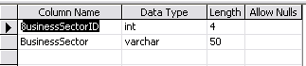

City Details

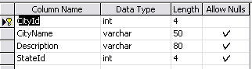

Country Details

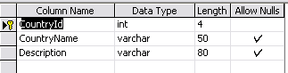

Experience Detail

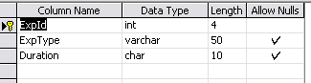

Functional Area

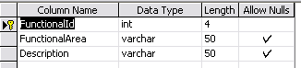

Job Openinng Detail

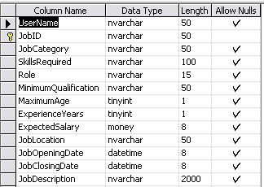

Jobseeker Response to Recruiter

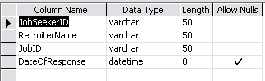

Job Type Detail

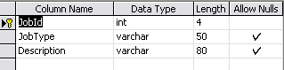

Location Master

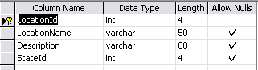

Qualification

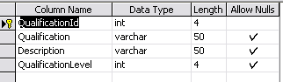

Recruiter Account Details

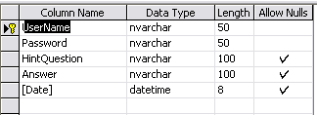

Recruiter Organization Details

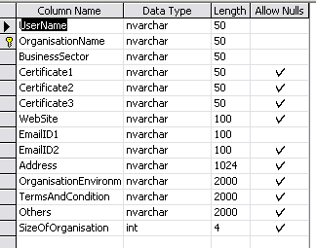

Recruiter Response to Jobseeker

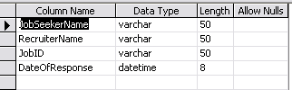

Skill Master

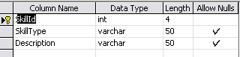

State detail

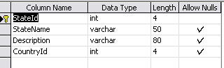

Student Detail

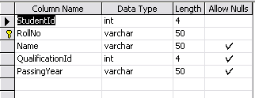

Admin Login

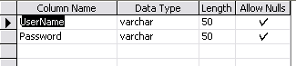

Jobseeker Background Details

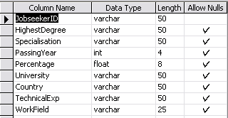

Contact Details

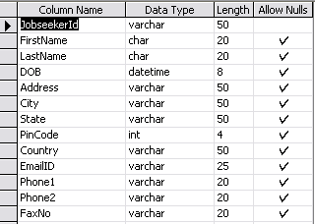

Jobseeker Job Details

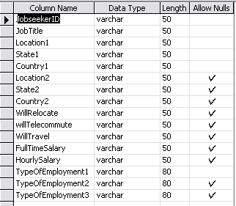

Jobseeker Registration

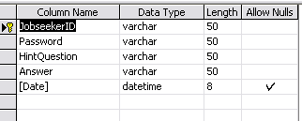

Jobseeker Resume

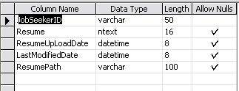

Jobseeker Technical Details

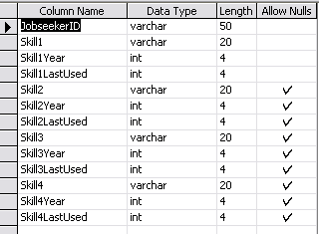

**BENEFITS:**

The project is identified by the merits of the system offered to the user. The merits of this project are as follows: -

* It’s a web-enabled project.
* This project offers user to enter the data through simple and interactive forms. This is very helpful for the client to enter the desired information through so much simplicity.
* The user is mainly more concerned about the validity of the data, whatever he is entering. There are checks on every stages of any new creation, data entry or updation so that the user cannot enter the invalid data, which can create problems at later date.